31330 Human neutrophil elastase (NE) immunoassay kit

Introduction of molecule

Neutrophil elastase (NE), also known as leukocyte elastase, serine elastase, and elaszym, is one of the hematopoietic serine proteases localized in the primary granules of polymorphonuclear neutrophils (PMNs)¹. The primary function of NE is recognized as to participate in the clearance of invaded pathogens through its intracellular and extracellular killing as well as antimicrobial activity, and the degradation of extracellular matrix components, including elastin, collagens, fibroncetin and proteoglycans².

Performance and characteristics of assay

A. Typical representation of standard curve

The following standard curve is provided for demonstration only. A standard curve should be generated for each set of sample assay.

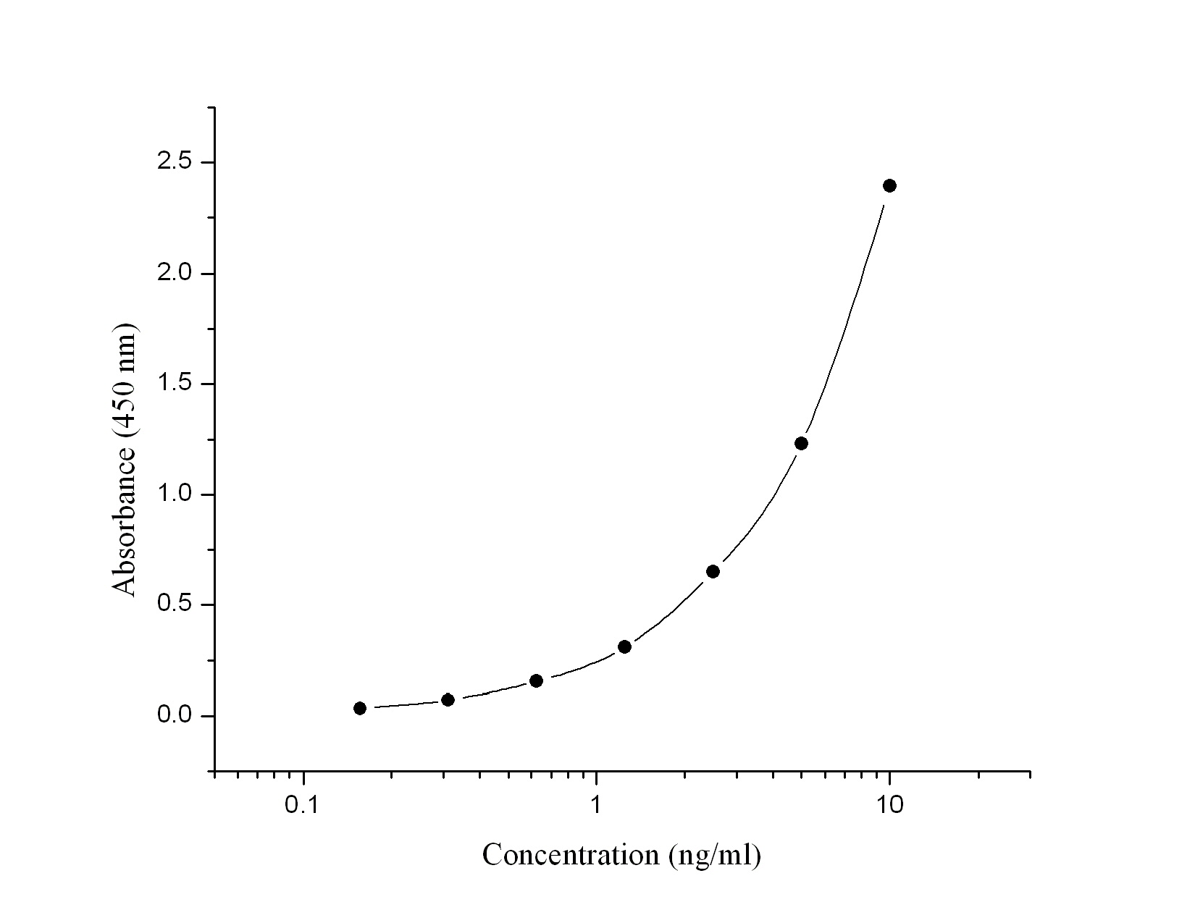
Human NE standard curve (4-parameter)

Human NE (ng/ml) | Absorbance  (450 nm) | Blanked Absorbance
0 | 0.07 | 0
0.156 | 0.105 | 0.035
0.312 | 0.142 | 0.072
0.625 | 0.225 | 0.155
1.25 | 0.379 | 0.309
2.5 | 0.72 | 0.65
5 | 1.3 | 1.23
10 | 2.463 | 2.393

B. Sensitivity: Will update soon

C. Precision: Will update soon

D. Recovery: Will update soon

E. Specificity: Will update soon

F. Linearity: Will update soon

G. Sample : Serum and plasma

H. Storage : 4°C

REFERENCES
1. Korkmaz B et al., (2008) Biochimie 90:227-242.
2. Ginzberg HH et al., (2001) Am J Physiol Gastrointest Liver Physiol 281:G705-717.

