36009- Equine insulin immunoassay kit

Introduction of molecule
Insulin is a hormone synthesized by the β cells of pancreatic islets. It consists of two amino acid chains, A chain and B chain, linked with a sulphide bond. The A chain is made of 21 amino acids and B chain with 30 amino acids. Insulin has a molecular weight of 5.8KDa¹.

Performance and characteristics of assay

A. Typical representation of standard curve

The following standard curve is provided for demonstration only. A standard curve should be generated for each assay.

Insulin (µU/ml) | Absorbance  (450 nm) | Blanked Absorbance
0 | 0.052 | 0
3 | 0.074 | 0.022
6 | 0.114 | 0.062
12 | 0.226 | 0.174
25 | 0.549 | 0.497
50 | 1.189 | 1.137
120 | 2.705 | 2.653
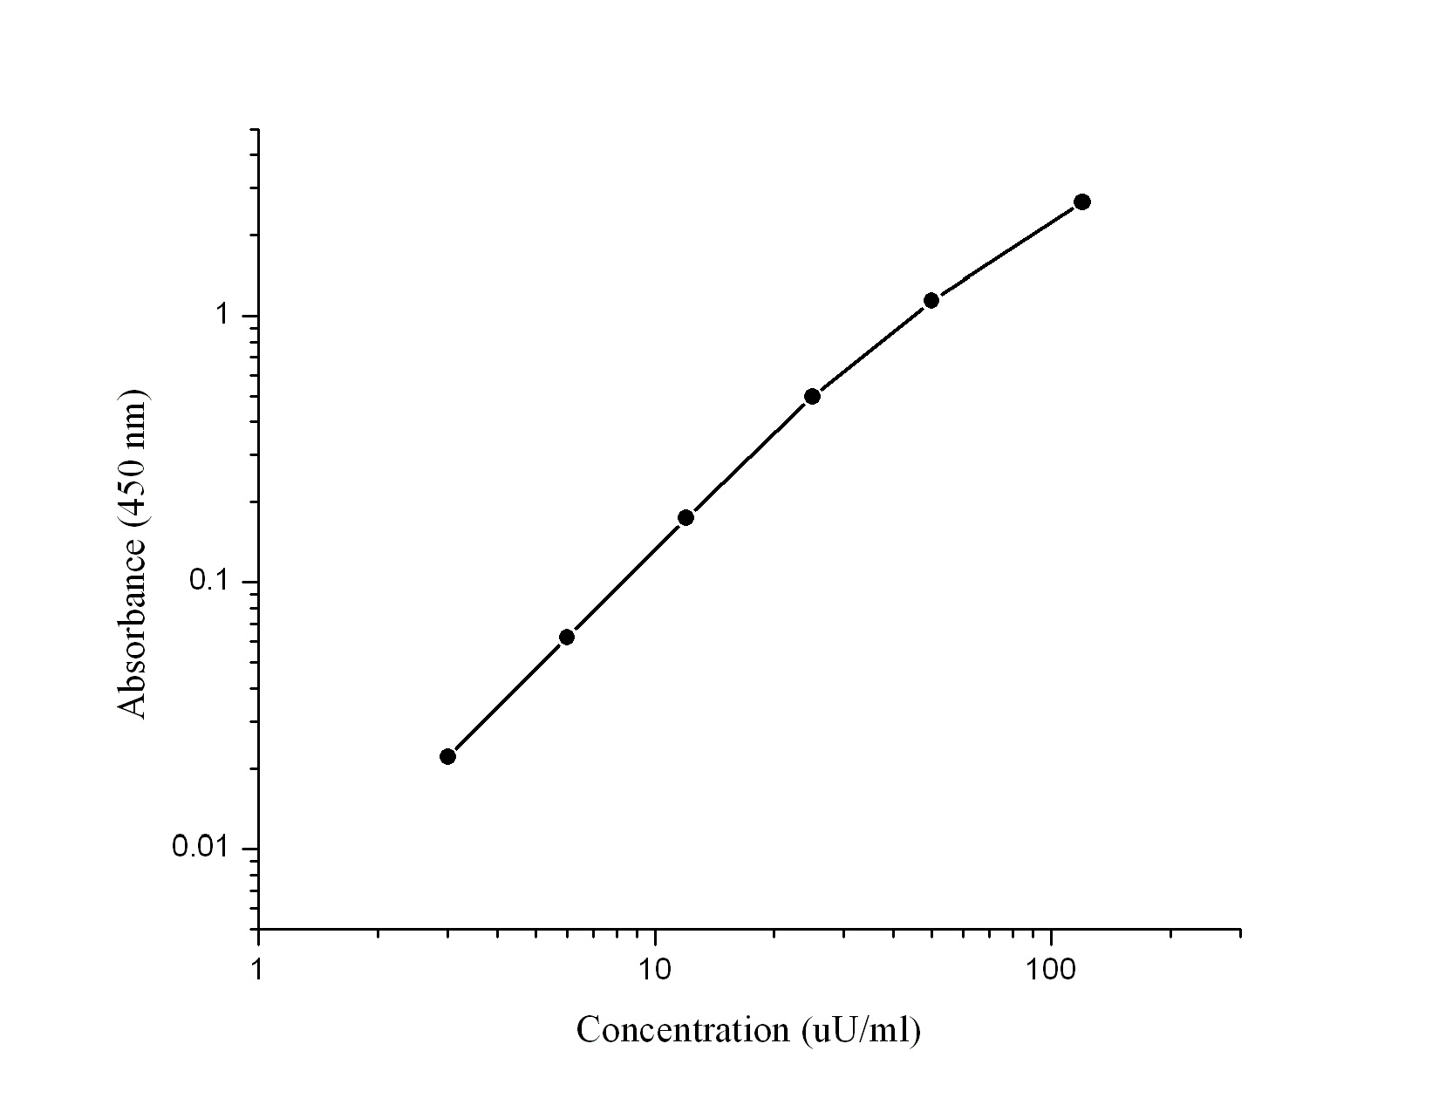

B. Sensitivity
The lowest insulin level that can be measured by this assay is 3µU/ml.

C. Precision
Intra-assay Precision (Precision within an assay) C.V. < 10%.
Inter-assay Precision (Precision between assays) C.V. <10%.

D. Recovery
The recovery of the assay was determined by adding various amounts insulin to a sample. The measured concentration of the spiked sample in the assay was compared to the expected concentration. The average recovery was 92%.

E. Specificity: Will update soon

F. Sample : Serum and plasma

G. Storage: 4°C

References
- Mane K et al.,(2012) J Basic Clin Pharm 3(2):283-293

