The α1-Microglobulin Turbidimetric Immunoassay Reagent Kit

Catalogue number:

For the quantitative determination of α1-Microglobulin
in human serum and plasma

This package insert must be read in its entirety before using this product
Use only the current version of product data sheet enclosed with the kit

Website: www.immunodiagnostics.com.hk
E-mail: info@immunodiagnostics.com.hk
Tel: (+852) 3502 2780
Fax: (+852) 3502 2781

FOR RESEARCH USE ONLY
NOT FOR USE IN DIAGNOSTIC PROCEDURES

TABLE OF CONTENT
Content | Page
INTRODUCTION | 1
PRINCIPLE OF THE ASSAY | 1
REAGENTS SUPPLIED | 2
OTHER MATERIALS REQUIRED, BUT NOT PROVIDED | 2
STORAGE | 2
SAMPLE HANDLING | 2
ASSAY PROCEDURE | 3
TYPICAL STANDARD CURVE | 3
CALCULATION | 4
ASSAY CHARACTERISTICS | 4

Introduction

α1-Microglobulin (A1M), also known as Protein HC, is a kind of small globular protein, which can be found in blood plasma and extravascular tissues of all organs. It is produced in most cells of the body, but mainly in the liver. A1M functions as a kind of radical scavenger and reductase, which continuously remove free radicals and also oxidizing agents, mainly heme from the tissues. This can help protect cells and also tissues from damages.

A1M is subsequently transported to liver, where it will be broken down. However, in the case of proteinuria, A1M cannot be completely broken down in the kidney, which will result in the accumulation of A1M in the bloodstream. Therefore, A1M can be used as marker for proteinuria. The result is positive when A1M level exceeds 30 mg/L or the ratio of A1M (in milligrams) and creatinine (in millimoles) in the urine is over 0.7 mg/mmol

PRINCIPLE OF THE ASSAY

This assay is a turbidimetric immunoassay for the quantitative measurement of A1M in human serum and plasma. A standard or sample is added into a cuvette and mixed with the reaction buffer R1. After a short incubation, the test reagent R2, which is a suspension of microparticles coated with A1M antibodies, is added into the cuvette and mixed. The presence of A1M in the standard or sample causes the immune-particles to aggregate. The extent to which the microparticles aggregate is quantified by the amount of light scattering measured as absorbance by a chemistry analyzer. The concentration of A1M in unknown samples can be interpolated from a reference curve using the standards provided.

REAGENTS SUPPLIED

R1 – Reaction buffer, 30 ml, a ready-to-use buffer solution containing salt, polyether compound and preservative

R2 – Test reagent, 10 ml, a ready-to-use suspension of polymer microparticles coated with rabbit anti-A1M polyclonal antibodies in storage buffer

OTHER MATERIALS REQUIRED, BUT NOT PROVIDED

- Clinical chemistry analyzer
- α1-Microglobulin calibrators and controls
- Deionized water
- Analyzer-specific reagent containers for R1 and R2

STORAGE

The kit should be stored at 2-8°C upon receipt. Once opened, the reagents may be stored at 2-8°C for up to 4 weeks.

SAMLE HANDLING

This kit can be used to determine A1M in human serum and plasma samples. Blood specimens should be collected aseptically into appropriate tubes. Plasma should be prepared by standard techniques for laboratory testing. The prepared specimens should be stored in closed vessels. If the assay cannot be performed within 24 hours or specimens are to be shipped, the specimens should be frozen at −20°C or below. For long-term storage of specimens, −70°C or below is recommended. To avoid freeze-thaw cycles, specimens should be aliquoted. Do not use hemolyzed, hyperlipemic, heat-treated or contaminated specimens. No dilution of the sample is required in this assay.

Assay procedure

Assay procedures may vary depending on the automated chemistry analyzer to be used. A general example of assay procedures is stated as follow:
- Dispense 300µl of R1 into a clean cuvette
- Add 3µl of sample and incubate at 37˚C for 5 minutes
- Further add 100µl of R2
- Read change of absorbance at Main Wavelength 570 nm for 8 minutes after the addition of R2
- Calculate the concentration of A1M in unknown sample by interpolation from a reference curve using the standards provided

Typical standard curve

The following standard curve is provided for demonstration only. A standard curve should be generated for each assay.
A1M (mg/L) | Absorbance
0 | -0.098
6 | 0.450
12 | 0.950
25 | 2.185
50 | 3.345
100 | 4.376

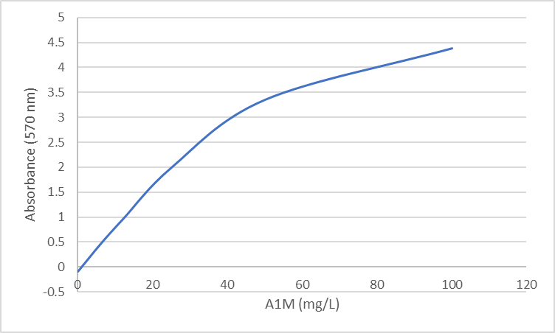
Calculation

- Subtract the absorbance of the blank from that of standards and samples.
- Generate a standard curve by plotting the absorbance obtained (y-axis) against A1M concentrations (x-axis). The best fit line can be generated with any curve-fitting software by regression analysis. 4-parameter curve fitting can be used for calculation.
- Determine A1M concentration of samples from standard curve.

ASSAY CHARACTERISTICS

A. Sensitivity
The sensitivity is defined as the lower limit of detection and is estimated as the mean of the blank sample plus three times the SD obtained from the blank sample. The sensitivity of A1M assay is 0.181mg/L.

B. Precision
The precision of the A1M assay is < 10% CV. Two samples consisting of serum based panels were assayed 20 times separately.

Sample | Mean A1M  (mg/L) | SD  (mg/L) | CV
Panel 1 | 17.7 | 0.2 | 1.20%
Panel 2 | 32.4 | 1.0 | 3.00%

C. Linearity
The A1M assay is linear between 6 mg/L to 100 mg/L.

D. Interference
No interference was detected with hemoglobin up to 5 g/L, conjugated bilirubin up to 300 mg/L, free bilirubin up to 300 mg/L, and up to 5g/L lipid emulsion.

5F, Biotech Centre 2 (11W), No. 11 Science Park
West Avenue, Hong Kong Science Park, Shatin. NT, Hong Kong
Website: www.immunodiagnostics.com.hk
E-mail: sales@immunodiagnostics.com.hk
Tel: (+852) 3502 2780
Fax: (+852) 3502 2781
ImmunoDiagnostics Limited

