31700 Human PM20D1 immunoassay kit

Introduction of molecule

PM20D1 is a bidirectional N-fatty-acyl amino acid synthase/hydrolase that regulates the production of N-fatty-acyl amino acids. These metabolites are endogenous chemical uncouplers of mitochondrial respiration. In an UCP1-independent manner, maybe through interaction with mitochondrial transporters, they promote proton leakage into the mitochondrial matrix. PM20D1 may indirectly regulate the bodily dissipation of chemical energy as heat through thermogenic respiration.

Performance and characteristics of assay

A. Typical representation of standard curve

The following standard curve is provided for demonstration only. A standard curve should be generated for each set of sample assay.

Human PM20D1 standard curve （4 parameters）
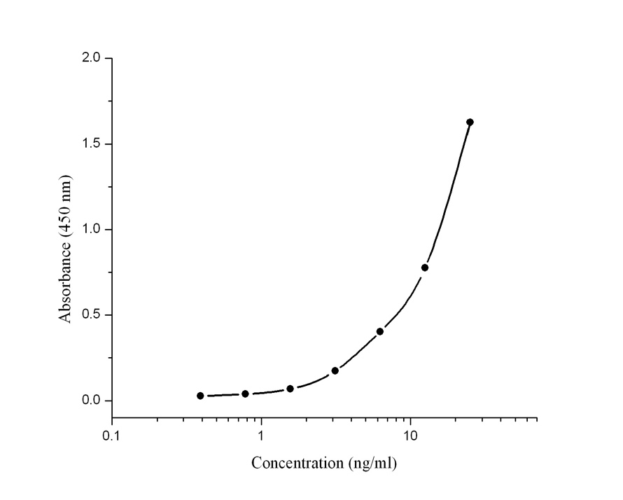
Human PM20D1(ng/ml) | Absorbance  (450 nm) | Blanked Absorbance
0 | 0.105 | 0
0.39 | 0.131 | 0.03
0.78 | 0.139 | 0.043
1.56 | 0.162 | 0.079
3.125 | 0.25 | 0.202
6.25 | 0.505 | 0.404
12.5 | 0.846 | 0.809
25 | 1.74 | 1.615

B. Sensitivity:
The lowest level of human PM20D1 that can be measured by this assay is 0.209 ng/ml.

C. Precision:
Intra-assay Precision (Precision within an assay) < 3.7%.
Inter-assay Precision (Precision between assays) < 3.8%.
D. Spike
Serum samples were assayed by adding 90 µl of
sample and 10 µl of spike stock solution calculated
to yield the intended 0, 1.25, 5 or 20 ng/ml spike
concentration

Spike level | Expected  (ng/ml) | Observed  (ng/ml) | Recovery (%)
Low spike (1.25 ng/ml) | 1.25 | 1.22 | 98
Medium spike (5 ng/ml) | 5 | 5.32 | 106.5
High spike (20 ng/ml) | 20 | 18.65 | 93.2

E. Specificity: No cross reactivity with recombinant mouse PM20D1 protein

F. Linearity: To assess the linearity of the assay, samples containing and/or spiked with high concentrations of human PM20D1 were serially diluted with the 1×Assay buffer to produce samples with values within the dynamic range of the assay.
Sample 1
 | Dilution | Measured (ng/ml) |  | Expected (ng/ml) |  | Recovery (%)
 | 1/2 | 10.11 |  | 9.51 |  | 106.3
 | 1/4 | 4.91 |  | 4.9 |  | 100.2
 | 1/8 | 2.56 |  | 2.69 |  | 95.2

G. Sample : Serum and plasma
H. Storage : 4°C

