31300- Human Proteinase 3 (PR3) immunoassay kit

Introduction of molecule

Proteinase 3 (PR3), also known as myeloblastin, azurophil granule protein-7 or p29b, PRTN3 and NP- 4, is one of the hematopoietic serine proteases localized in the primary granules of polymorphonuclear neutrophils (PMNs). It is a 29kDa glycoprotein made of 222 amino acids and is released during neutrophilic inflammation².

Performance and characteristics of assay

A. Typical representation of standard curve

The following standard curve is provided for demonstration only. A standard curve should be generated for each set of sample assay.

Human PR3 standard curve (4-parameter)
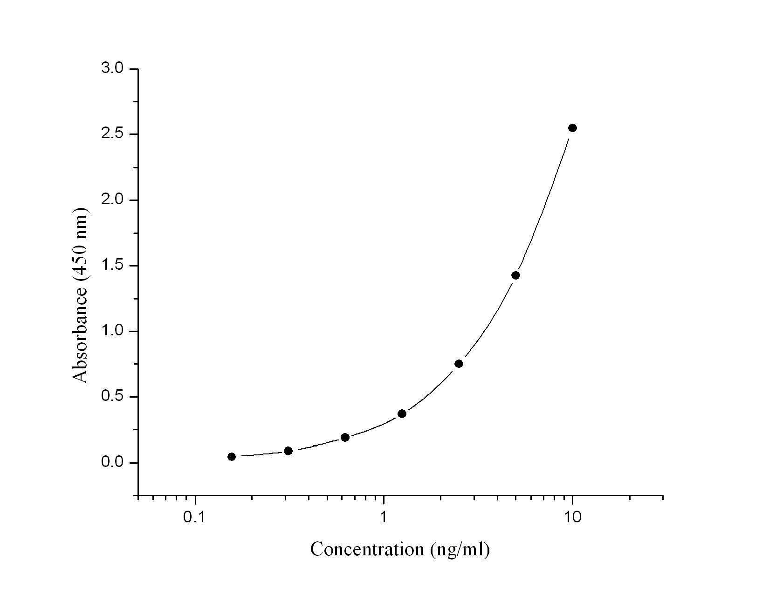

Human PR3 (ng/ml) | Absorbance (450 nm) | Blanked Absorbance
0 | 0.056 | 0
0.156 | 0.102 | 0.046
0.312 | 0.145 | 0.089
0.625 | 0.245 | 0.189
1.25 | 0.426 | 0.37
2.5 | 0.808 | 0.752
5 | 1.482 | 1.426
10 | 2.603 | 2.547

B. Sensitivity: Will update soon

C. Precision: Will update soon

D. Recovery: Will update soon

E. Specificity: Will update soon

F. Linearity: Will update soon

G. Sample : Serum and plasma

H. Storage : 4°C

REFERENCES

- Pham CT (2006) Nat Rev Immunol 6:541-550
- Crisford H et al., (2018) Respir Res 19:180

