31980- Human GDF-15 immunoassay kit

Introduction of molecule

Growth differentiation factor 15 (GDF-15) belongs to transforming growth factor β family¹. The biologically active form of GDF-15 is a 28 kDa disulphide linked homodimer².It is also known as macrophage inhibiting cytokine 1 (MIC-1), placental transformation growth factor (PTGF-β), prostate derived factor (PDF),placental bone morphogenetic protein (PLAB), NSAID activated gene-1 (NAG-1) and PL74¹.

Performance and characteristics of assay

A. Typical representation of standard curve
The following standard curve is provided for demonstration only. A standard curve should be generated for each set of sample assay.

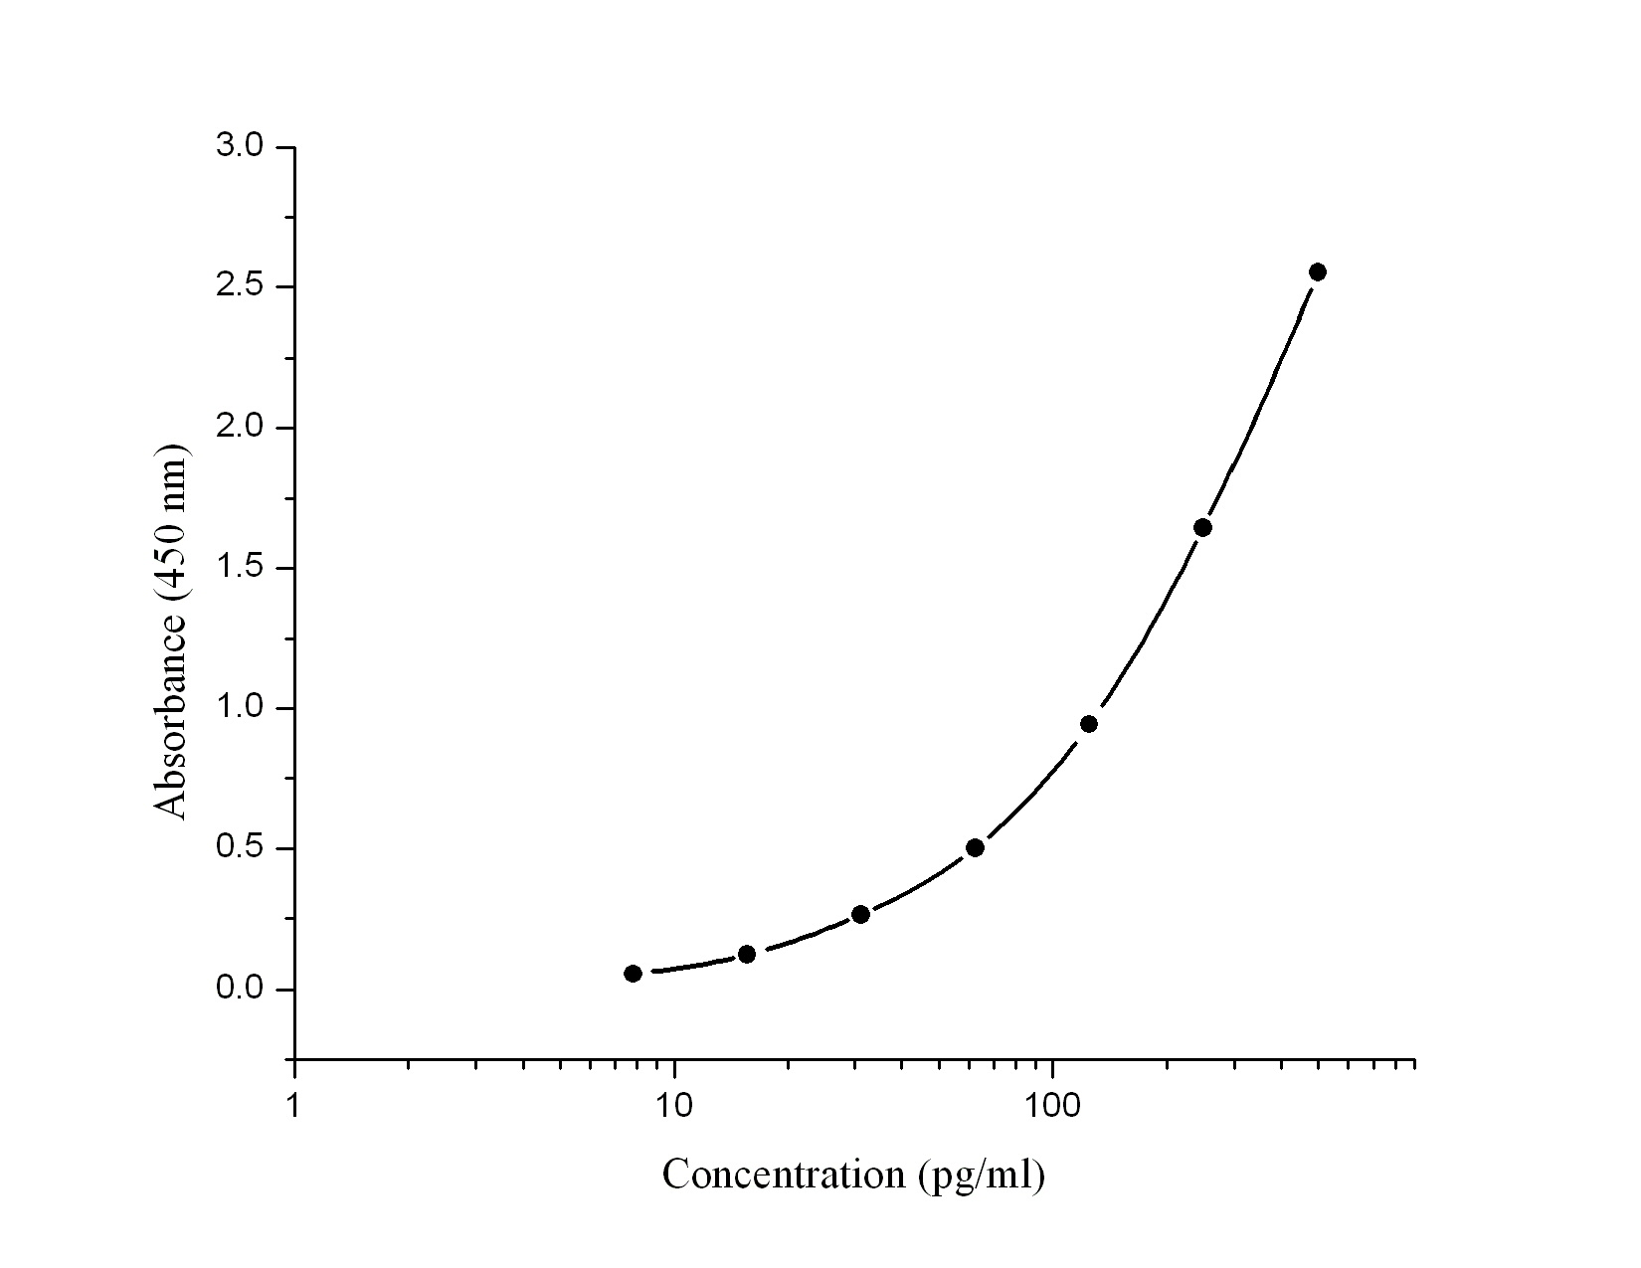
Human GDF-15 standard curve (4-parameter)
Human GDF-15 (pg/ml) | Absorbance  (450 nm) | Blanked Absorbance
0 | 0.074 | 0
7.8 | 0.13 | 0.056
15.6 | 0.197 | 0.123
31.2 | 0.338 | 0.264
62.5 | 0.577 | 0.503
125 | 1.017 | 0.943
250 | 1.719 | 1.645
500 | 2.626 | 2.552

B. Sensitivity:
The lowest level of human GDF-15 that can be detected by this assay is 7.8 pg/ml.

C. Precision:
Intra-assay Precision (Precision within an assay) <10%.
Inter-assay Precision (Precision between assays) <10%.

D. Recovery: Will update soon

E. Specificity: Will update soon

F. Linearity: Will update soon

G. Sample : Serum and plasma

H. Storage : 4°C

REFERENCES

- Adela R & Banerjee SK (2015) J Diabetes Res 2015:1-14
- Baek SJ & Eling T (2019) Pharmacol Ther 198:46-58

